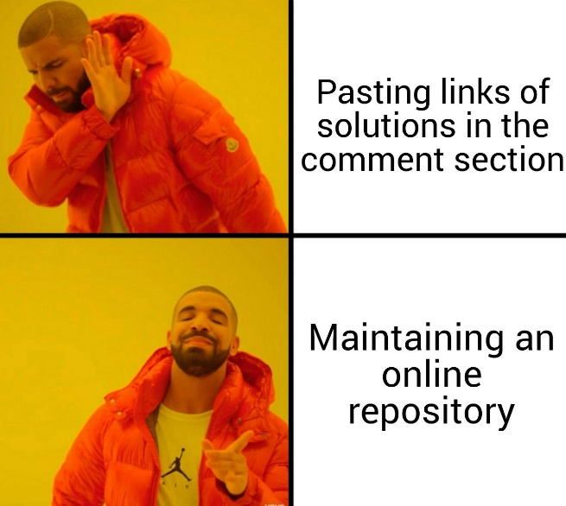

Maintaining an online repository of solutions

# Step 1: Create your account

Visit [this](https://github.com/join) link and create a Github account for yourself. It will really help you in the long run.

# Step 2: Create a repository

A repository (sometimes called a repo) is a container used to organise a project. Repositories contain all of the folders and files needed for your project. This can include text files, images, videos, or any other kind of file you could think of.

For the purpose of this summer assignment, we will create a repository called python-summer-sols.

1. Click the + sign next to your avatar in the top right corner and select New repository.
2. Name your repository python-summer-sols.
3. Write a short description of your project, like, “Repo for storing solutions of Python Summer Tutorials”.
4. Select Public.
5. Select Initialize this repository with a README.
6. Click Create repository.

A repository called python-summer-sols will then be created and you will be taken to the repository page. Note that the URL structure for the repository will be github.com/account-name/repository-name.

Don’t forget to add this url to the spreadsheet mentioned in the post.

# Step 3: Add a file to the repo

Now we have to start uploading our solutions to this repo. We will be following a folder structure similar to: python-summer-sols/tutorial_num/question_num.py, so as to keep the repo organised.

1. Click on “Create new file” button.
2. Type “tutorial_01/question_01.py” in the name field. (It will automatically detect that tutorial_01 is the name of the folder, so don’t worry if it already exists.)
3. Paste the solution in the text box.
4. Scroll down and press on the “Commit new file” button.

Repeat the above steps for other files.

This zip file contains videos of the steps mentioned above. Double click to open.



# Editing a file

To edit a file, simply press the Pencil icon after opening the file. After you are satisfied with the changes, simply press the “Commit changes” button at the bottom of the page.

# Deleting a file

Deleting a file is also just as easy. To do so, press the dustbin icon, and then click on Commit changes button in the next page.